Work Sample Walk Through Instructions

# WPILIFE

# Background Information:

At the beginning in 2017, members of CSSA(Chinese Scholar and Students Association) in Worcester Polytechnic Institute noticed that, due to graduation of the former developers, the official website is outdated and was no longer maintained. We decided to re-develop the whole website, utilizing new technologies and inheriting the basic functions of the old version, which includes providing survival guide for new students, second-hand items selling and WTB(want to buy) posting, renting and subleasing information and upcoming events schedule. The structure figure of the website is below.

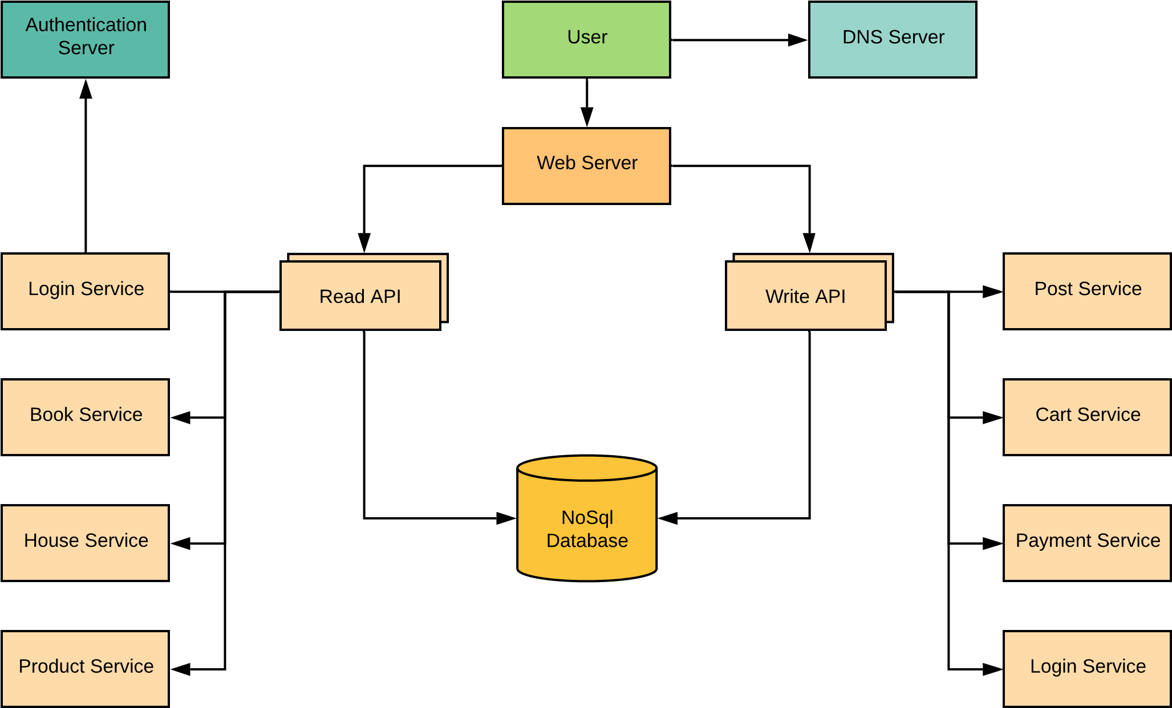

# Responsibilities

As a core develop team member, I was in charge of the design of the data schema, login/ sign on module, Housing and New Student pages.

# File documentation

Sample codes were divided into 2 folders by which end they are work at.

Backend folder contains Data schema folder, which includes all the schema we used in the website, and housing service.

Frontend folder contains housing, login, and new students folders, in which there are corresponding services, html file, css file, model file and a ts file for responsive presentation.

# Technology Framework Comparison

It was our first time to design a website, we were not sure about what the future requirements could be, so we decided to use separate front end and back end frameworks. In this case, we chose Angular over React as the front end framework and express as our backend framework.

As some of members did not have programming experience, the learning curve of some components of React such as jsx and flux are too hard. We did realize that as the website becomes heavier and heavier, the efficiency, due to two-ways data binding and dirty-checking, application implemented by Angular would be lower and lower, though, we did not think that our website could go that far or reach that scale.

Bootstrap was selected to bring responsive design in our website. Bootstrap has the largest ecosystem among front-end frameworks. The number of website layouts, themes, admin panels, UI components, etc., built using Bootstrap is mind-boggling, and it keeps getting better. With Bootstrap, there’s almost no need to spend thought on tricky CSS positioning and browser incompatibilities.

For authentication, we chose Auth0. Since we want to avoid the situation of filled with fraud like Craigslist, we want to restrict the user registration to valid WPI students. Auth0 allows us to fully customize any stage of the authentication and authorization pipeline to adapt to new policies, new applications, and new platforms. It also allows us to authenticate and authorize our application with office356 with simple APIs, which is beginner-friendly.

When discussion came to data storage, as we wanted to minimize the data migration cost when up-scaling the whole project. What’s more, NoSQL database is a much better fit to store data like article content, social media posts, sensor data, and other types of unstructured data, in this case, post containing items information, that won’t fit neatly into a table.

# Knowledge & Experience Acquisition

The first thing I learned is to start small and then extend. Always change one thing at a time. Multiple changes in one submit brings nothing but tons of bugs and pain. Keep communicating with teammates can avoid unnecessary time wasting and potential bugs. Integration is harder than it looks and do execute the code before merging it.

Error handling and logging is an important approach to debug and the earlier this part is added to the project the easier the testing would be.